

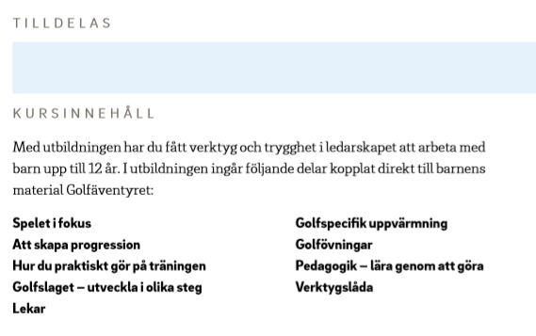

_______________________________ ______________________________

Utbildare Utbildare

